NCLC EXAM TABLETS
CP20 Android Tablet
Initial Configuration & Setup v240706
This is intended as instructions to configure a new CP20 Android Tablet for use in administering NCLC Laser Certification exams, supervised by an NCLC authorized Proctor. It is specific to the CP20 Android Tablet which the NCLC uses, but the steps generally apply to any device that will be setup and dedicated SOLEY for use to take proctored examinations and have no other use.
The configuration is intended to removal all other programs that are not essential to the online connection and testing. In configuring the device all optional personalization’s and all optional browser notifications and feedback will be skipped. At the conclusion of the setup the device will have ONLY the browser icon and setup icon available on the desktop. The browser will be configured for the NCLC Exam page login as its homepage and no other websites will be available in favorites. No other programs will be displayed nor accessible from the desktop. Students taking exams are to use only the browser ON THE NCLC EXAMINATION PAGE and no other use. Proctors enforce this by monitoring their screens during testing. Any other use of the browser or other programs, or any other indications of cheating, will lead to immediate termination of the exam. (the same as proctoring a written exam)
If you are an NCLC Exam Proctor and receive these tablets preconfigured from the NCLC, then you can skip these instructions and just move on to the instructions for use of the devices by the proctor.
You’ll still need to configure them for the connection to your internet router. Please KEEP the homepage of the browser set to the NCLC testing page so that it automatically goes there when they open the browser.
To connect the CP20 Android tablet to your router, follow these steps:
Turn on tablet / Settings / Network & Internet / Wi-Fi / Choose your router SSID / Enter Password
Allow it to remember your connection and connect automatically.
Screenshots for the steps to configure a “new” CP20 device for NCLC testing are:
(Note that various versions of the CP20 might be slightly different)
REMOVE THE TABLET AND CHARGER FROM THE ORIGINAL BOX:
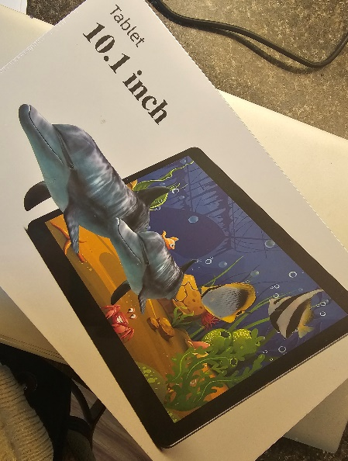
Note the product label and serial number for your records:
This is on the back of the device.
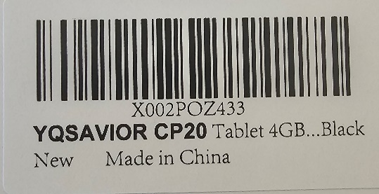

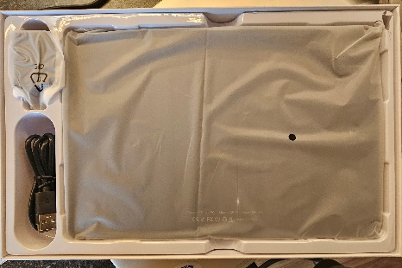
The tablet, charger and protective cover are in the box. You may keep these to store your unit, and/or store on portable multi tablet charger as needed.

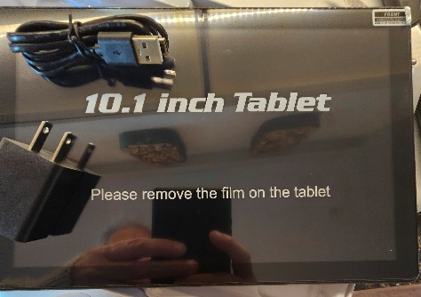

Remove the protective film from the tablet.

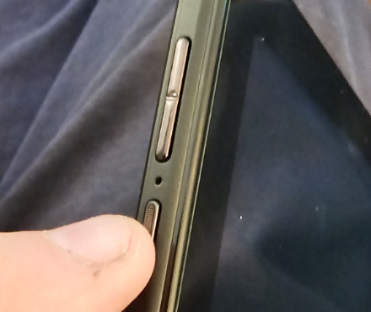

Turn on tablet/ Settings (Power button is the bottom one on left side of tablet – press & hold)
Power on the unit by pressing the button on the side of the tablet. If it does not have any initial charge to turn on, then of course connect the battery charger to it.
When the screen just comes up blue with no icons, then just “swipe up” to open it.
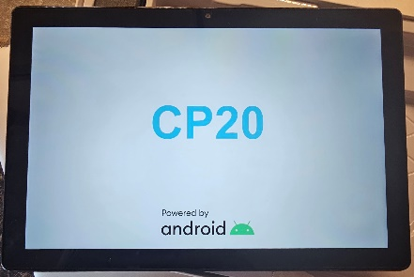

The initial CP20 display will soon come up.

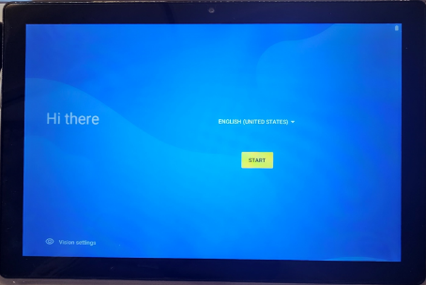
Since this is a new unit, it will start with the Welcome screen. It comes up with “English” selected as the default language. You can select others but remember that the NCLC exams are all in English.
You click the yellow “Start” button to continue.

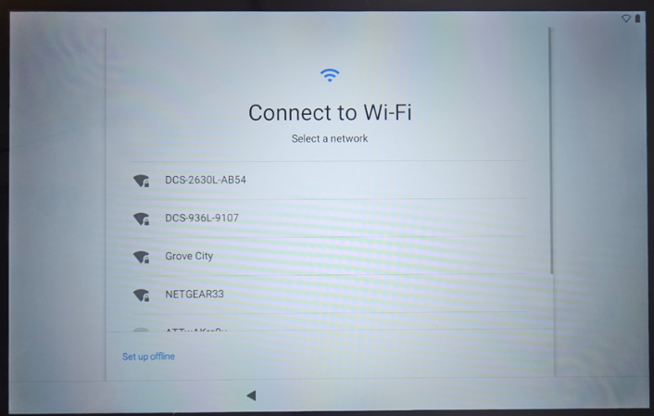
It will first ask you to connect to a WiFi network. This should be done in your testing/office location so that you have the network that students will be using when taking the online exams.

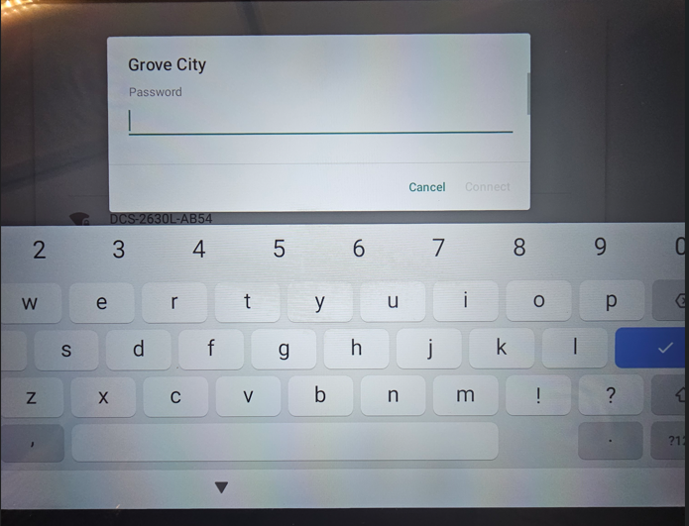
Once you select your network it will ask you to enter the password for that network.
Do that and “enter”.

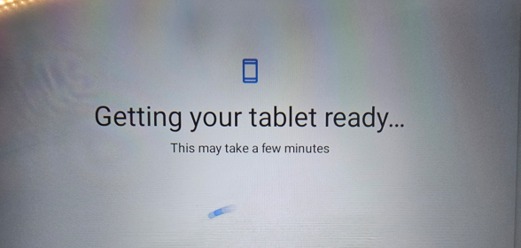
The “getting tablet ready” screen appears, and this may take a while before the next prompts.

Ooops! – Can’t Connect
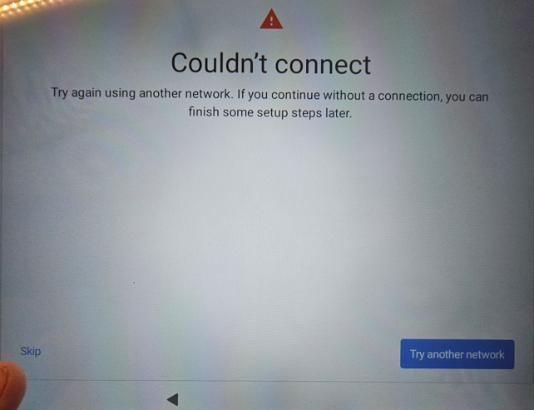
We’ve done this with several of these devices that just didn’t seem to make the internet connection at first. If this happens just touch the “Skip” button in the lower left to move on.
You can go back after the initial setup to connect to your network again. It then worked fine for us each time. Once you are connected it might want you update your tablet, but just follow the prompts.
If you don’t get this error, it will automatically go to the next screen, and you’ll get this too if you “skip”.
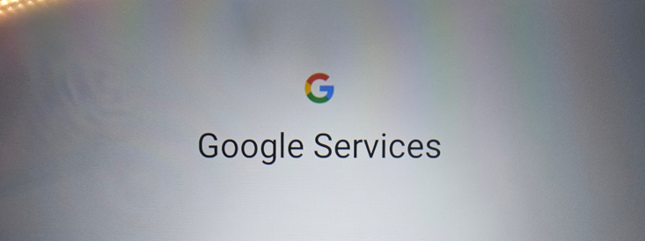
This is the first of many setup screens. For the most part you’ll decline all the setup options, accounts and importing data and files.

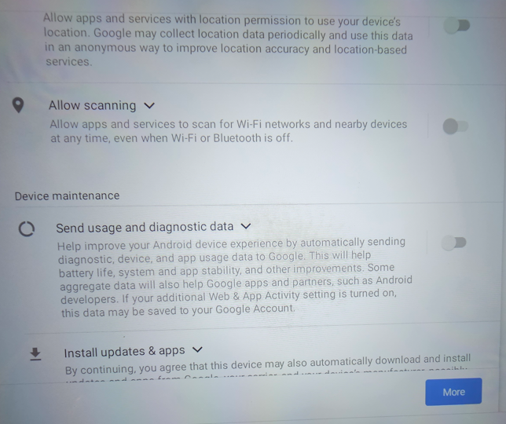
DON’T allow Scanning.
DON’T send usage and diagnostic data.
I don’t believe you have a choice in downloading updates, but you want that anyway.

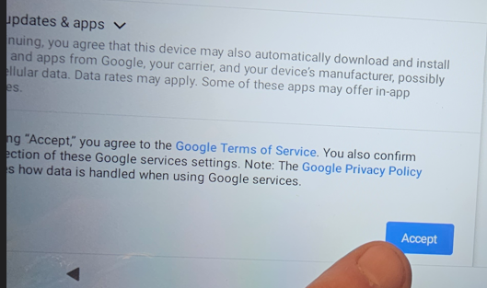
Once you’ve done that click the blue “accept” link at lower right.

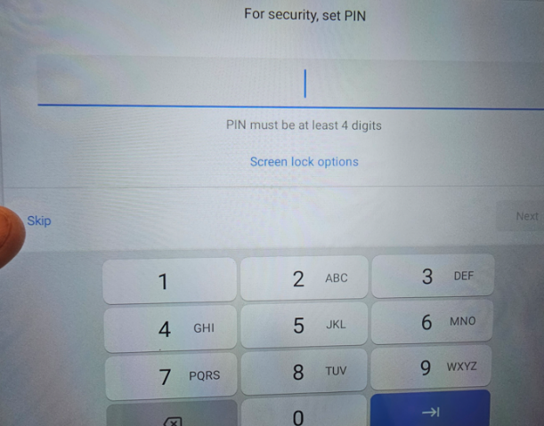
It now asks you to setup a security PIN to use the tablet. I’d suggest that you just SKIP this.
The only use of this tablet will be for testing, and having a PIN that gets forgotten or lost is just another chance for a problem. We skip it.
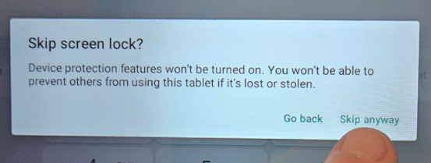

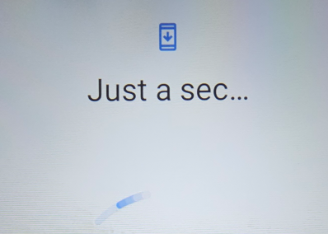

System processes……….

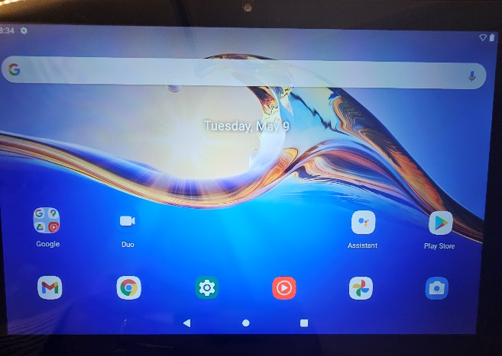
The Desktop now comes up. We want ALL ICONS OFF OF THIS, Except for the Browser and Settings icons.

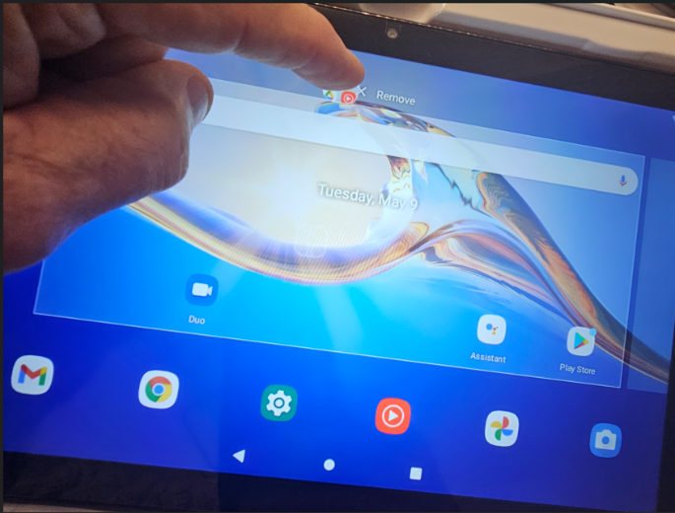
To get rid of them, touch the icon and pause. That selects it. Then you’ll drag it up to the top of the desktop. A “Remove” note appears and drag it to there to take if off the desktop. Do this with each icon EXCEPT the Chrome Browser and the Settings icons.

Do this one by one until you’re left ONLY with the browser and settings icons as shown here:
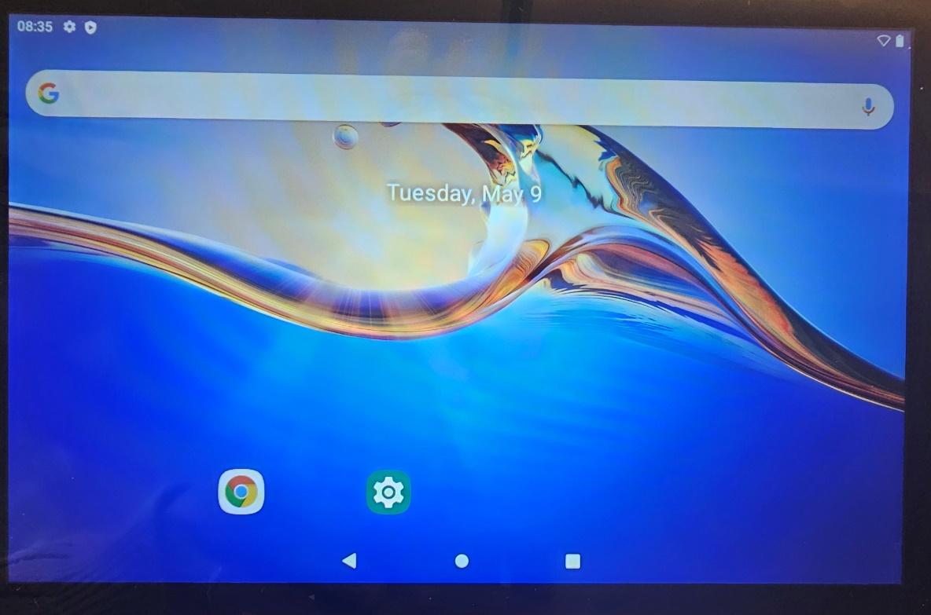

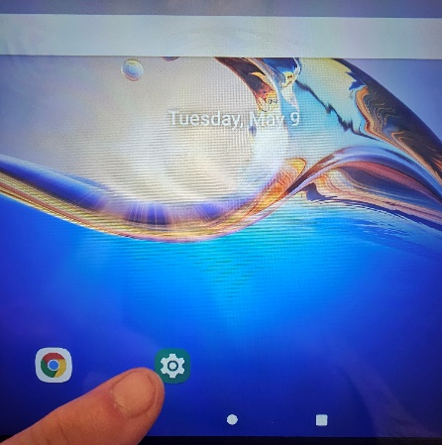
To continue configuring, tap the “Settings” Icon.

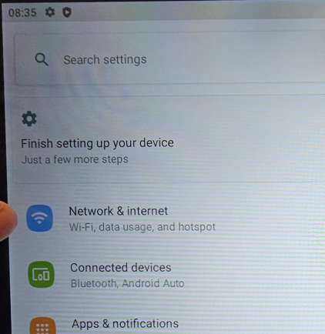
Select the “Network & Internet”

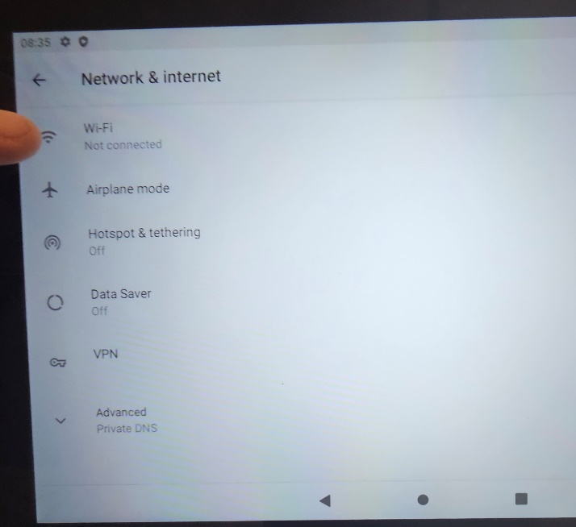

Then select the “WiFi” settings.
This assumes that you got that error code before about not being able to connect, and you now must set it up again. If it took the first time, then you’re already set.

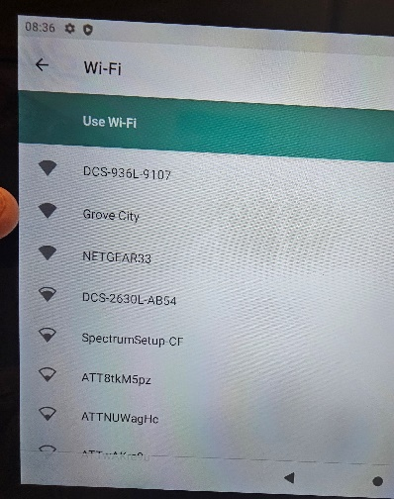
The list of available Wi-Fi connections will appear. Choose your connection which is where students will be connecting to take the exams.
Your internet connection needs to be fast and reliable.
In the NCLC offices, we also use a backup Wi-Fi network through a cellular “hotspot” device. This isn’t necessary if your internet service is reliable, but we use it as a “safety backup”. Use your discretion on backups in your own setting.

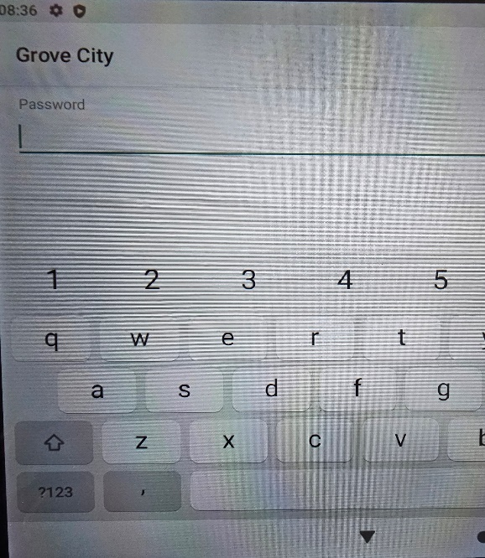
The wireless connection comes up again and asks you for the password to your internet router.
It should then come up and lists you as “connected” to your internet connection.
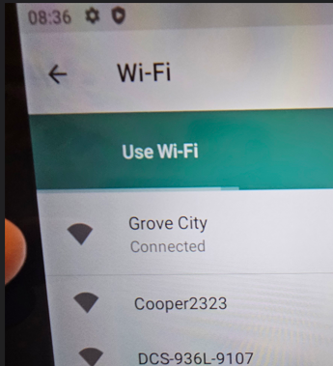

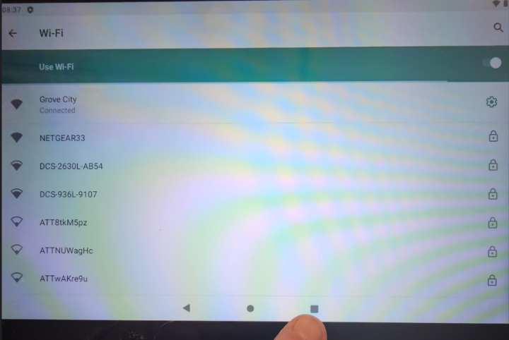
You can then close that window by tapping the square icon at the bottom right.

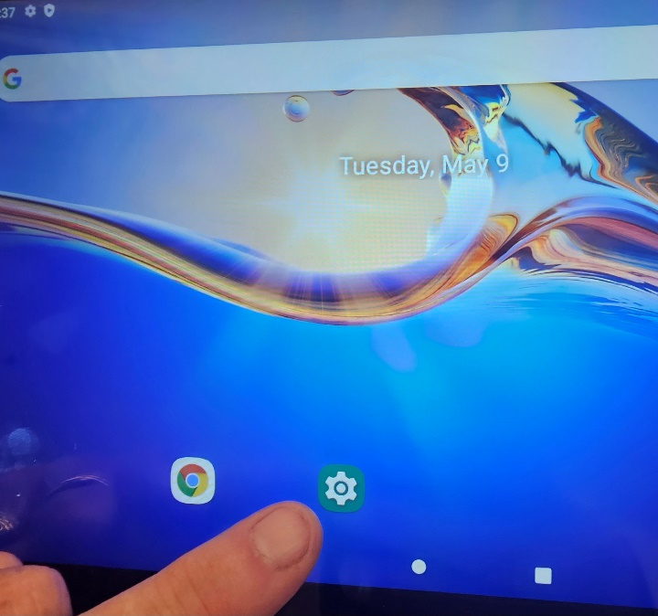

That should take you back to your desktop.
To continue the setup tap the green “Settings” icon.

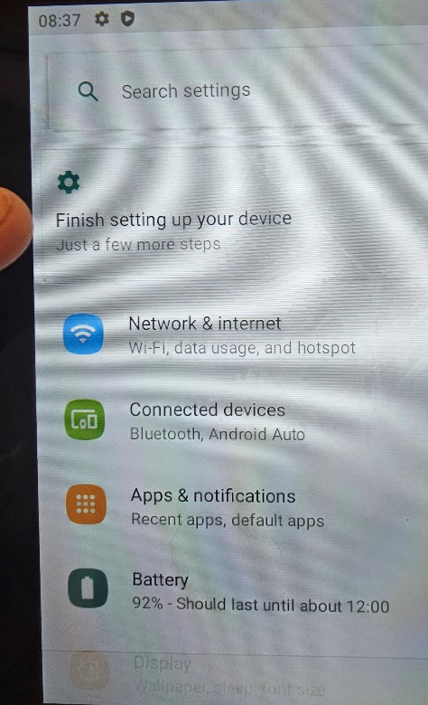
If there are still items waiting to be setup for the device you’ll see this “Finish setting up your device” icon. CLICK IT.
The “Finish CP20 setup” screen appears.
CLICK THE BLUE “START” BUTTON AT BOTTOM RIGHT.
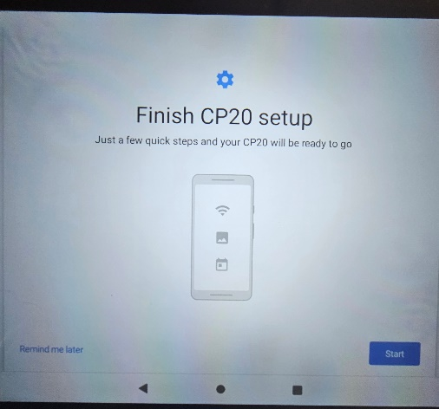

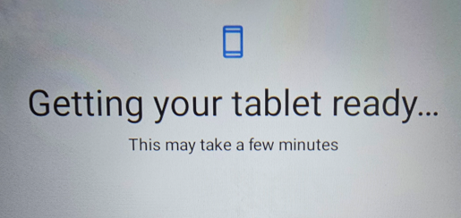
The “Getting Ready” screen appears.

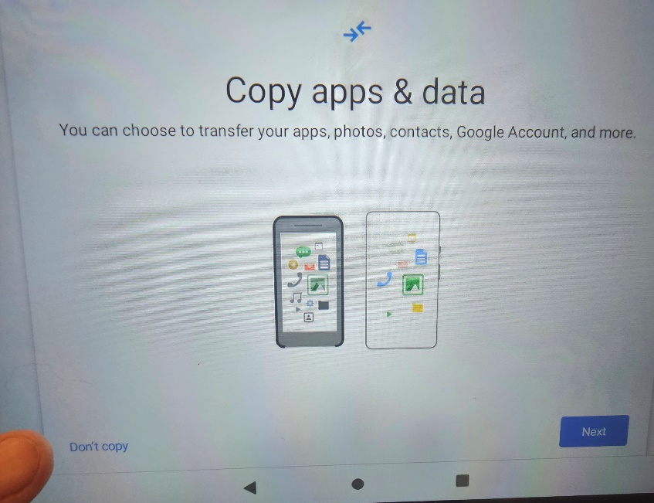
The “Copy apps & data” screen appears.
DO NOT COPY ANY APPS OR DATA INTO THIS DEVICE.
Tap the “Don’t Copy” link at the lower left.

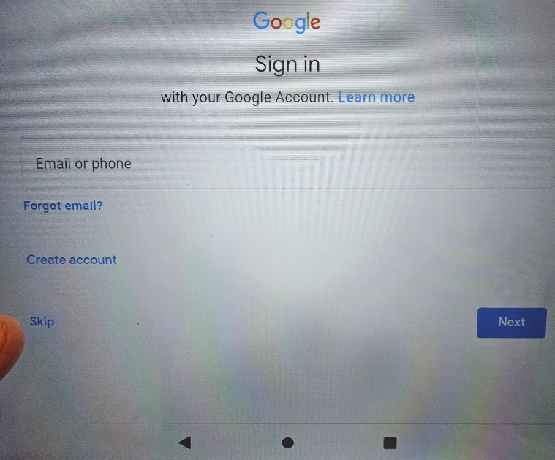

It now asks you to sign in to your Google Account.
DO NOT SIGN IN.
Hit the “Skip” link at lower left.

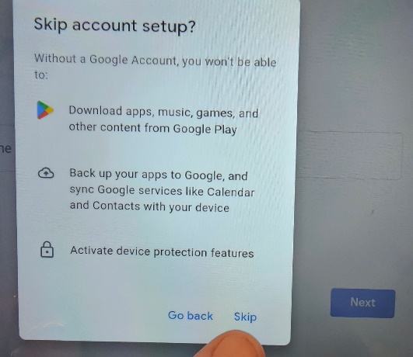
Confirm that you want to “Skip” this setup.

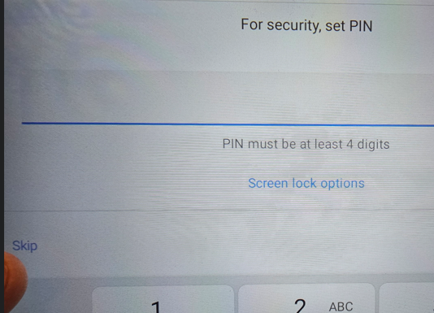
It might ask you again to set a security PIN.
SKIP THIS, and then confirm “Skip Anyway”.
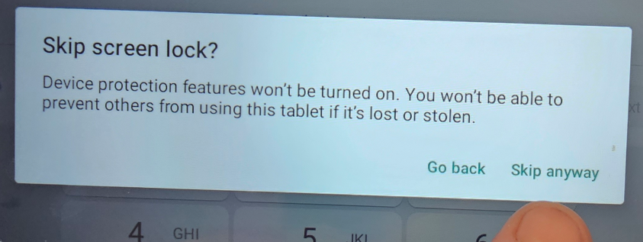

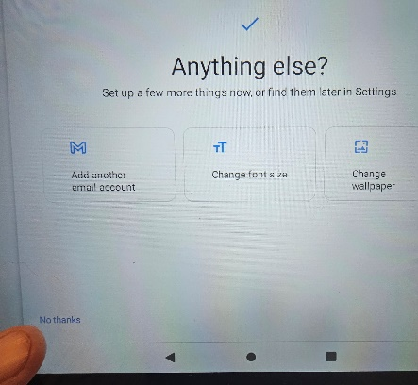
It wants to know if you want to do anything else.
( emails, fonts, wallpaper).
Just tap “No Thanks” at lower left.

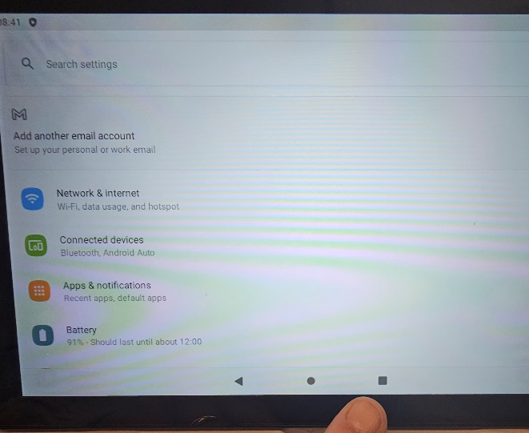
You can then close that window by tapping the dark square at lower right.

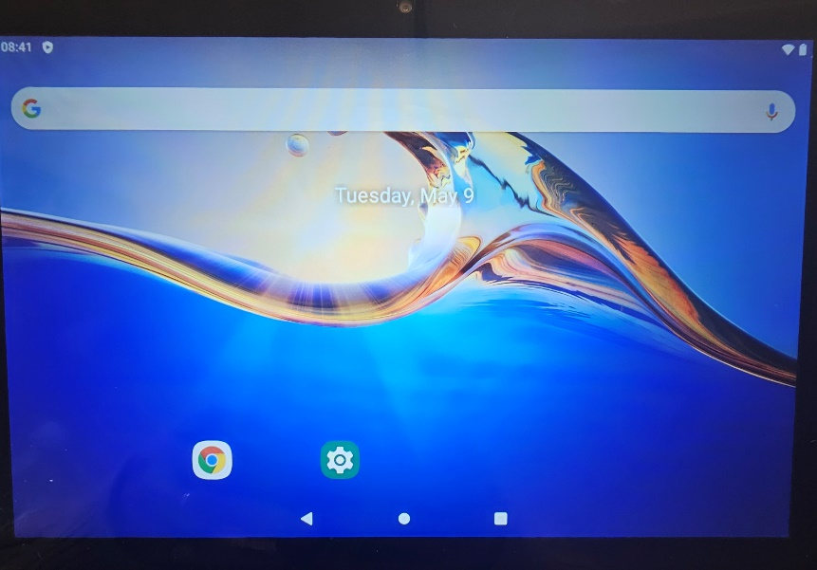
That should take you back to your desktop, and the only icons you see are the ones for the “Chrome Browser” and the “Settings” icons.

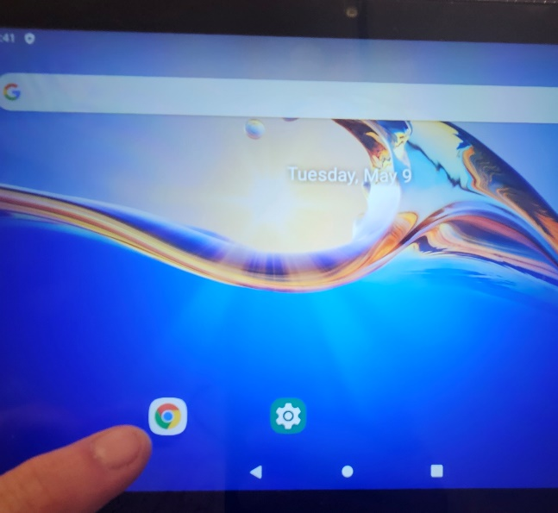
Now OPEN THE CHROME BROWSER BY TAPPING THE ICON.
You’ll configure it to use the NCLC online login page as the home page on the browser.

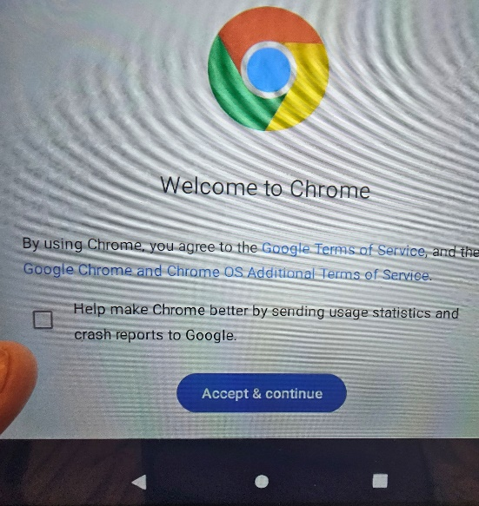
DO NOT CHECKMARK the
“Help make Chrome better…….” Link.

Just click the “Accept and Continue”.

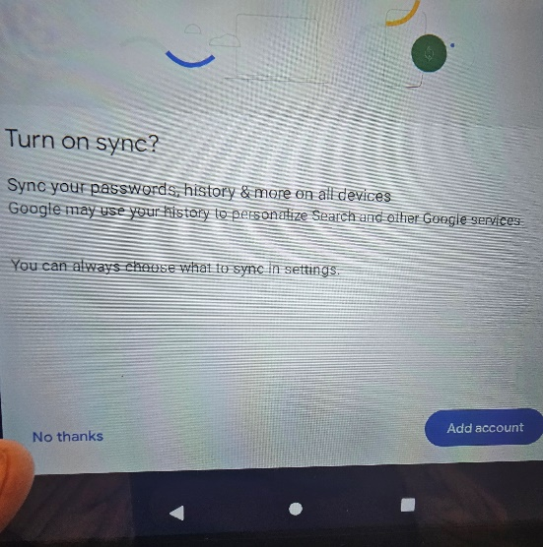

DO NOT TURN ON SYNCH.
Just tap the “No thanks” at lower left.

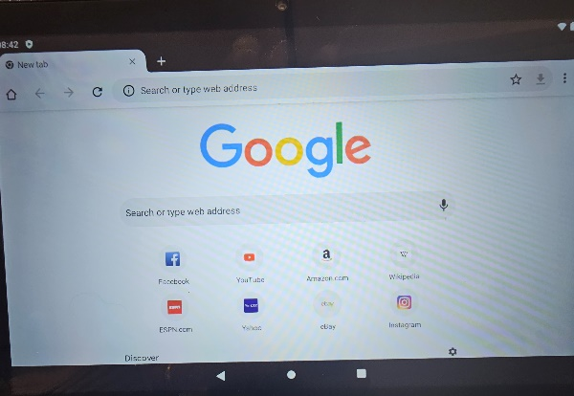
This takes you to Chrome’s Home Page.
We’re going to change that.

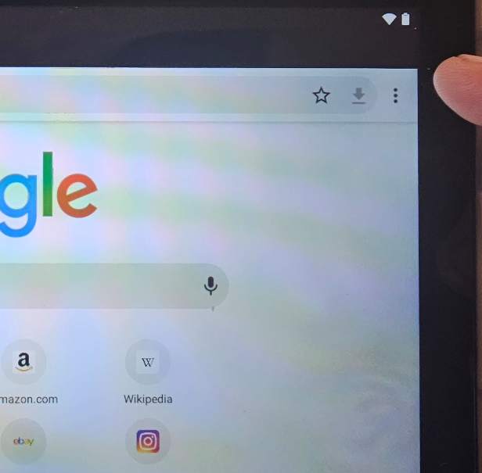
Tap on the three vertical dots at top right to open that menu. From the drop down menu choose “Settings”.
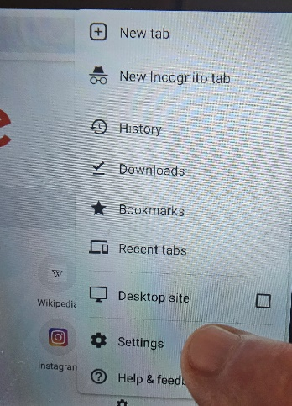

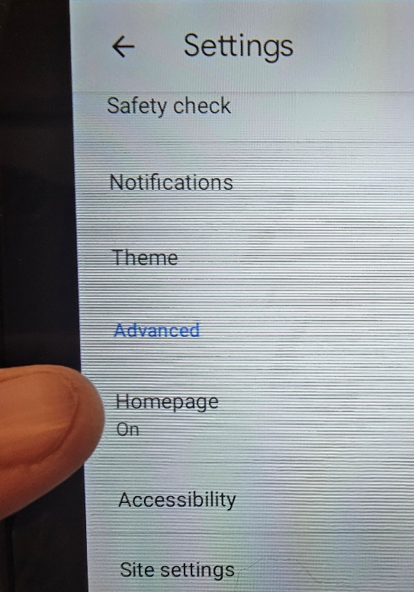

From that Settings drop down menu select “Homepage”.

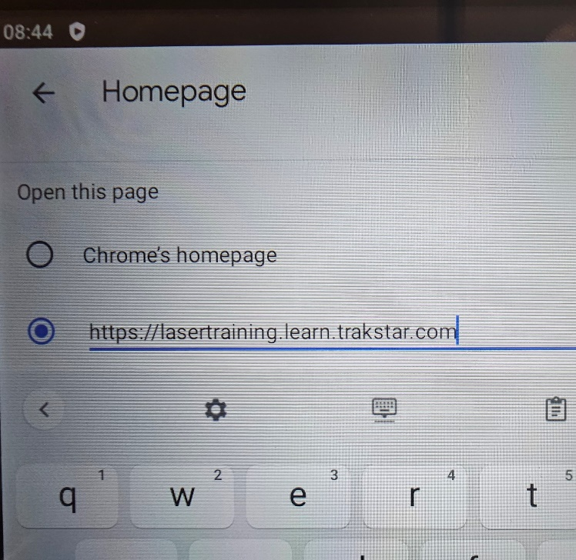
This is where you’ll enter the NCLC login page for online testing. The URL is: https://lasertraining.learn.trakstar.com

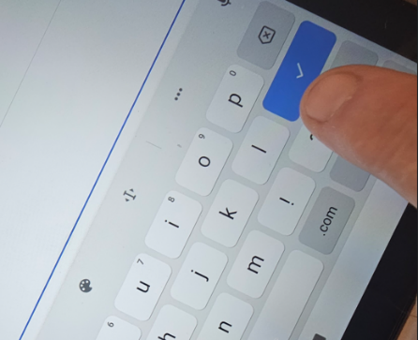
Once you’ve entered the new URL for home, just click the “done” button on the keyboard.

Start closing windows by using the back arrows:
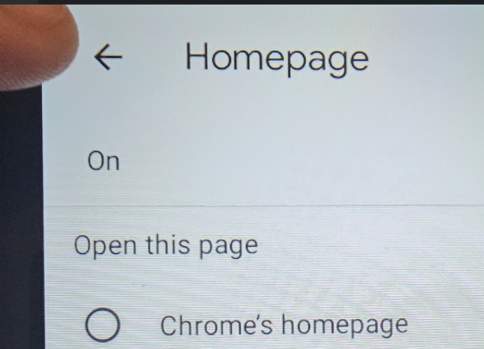
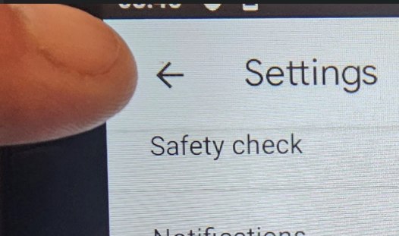
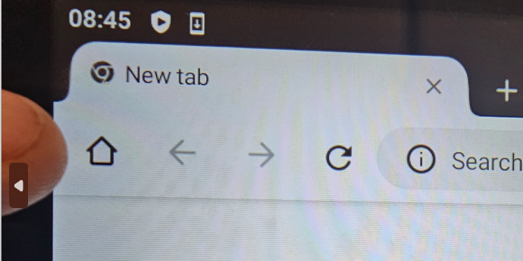
Now tap the “Home” icon on the browser, and it should take you to the testing page login.

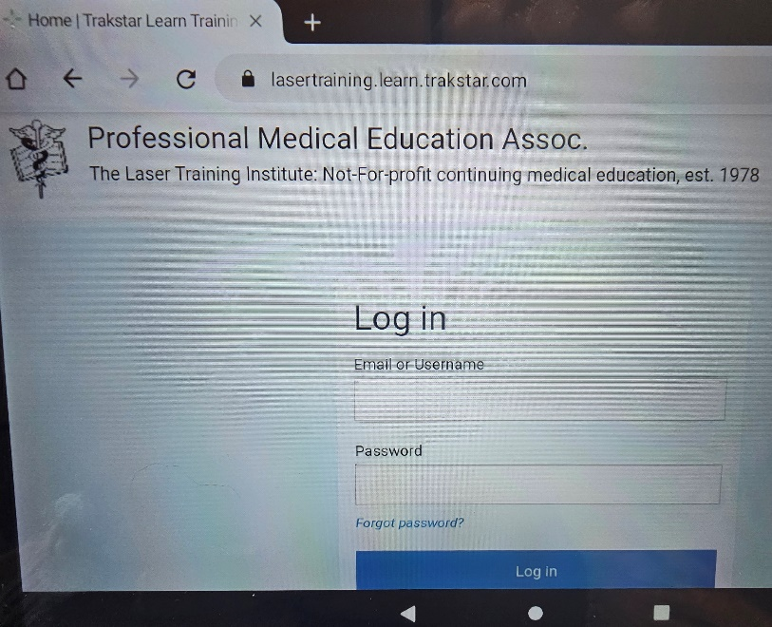
The new homepage for the browser is now set to https://lasertraining.learn.trakstar.com.
This is where examinees will enter their assigned username and password to login and start their exam. Proctors will be sent the usernames and passwords for each student after the exams have been ordered.
Proctors will carefully monitor examinees screens to ensure that they don’t leave the testing website and monitor for other forms of cheating as well.

When students have completed their testing, they should show their final screen to the proctor to ensure that they have completed the exam and not skipped any questions. This is covered in the next tutorial for Proctor Instructions on utilizing the devices for secure testing.
To power off the units press and hold the lower button on the side as you did when turning the unit on:
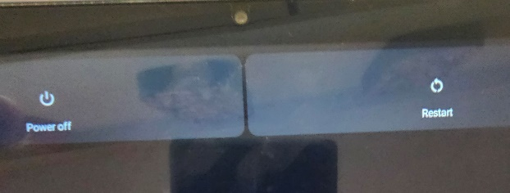

That brings up the “Power Off” or “Restart” on your screen.
Choose to “Power Off”.

The CP20 Android device is now configured for use for NCLC online examinations. All such exams must be given under the direct and continuous supervision of the assigned NCLC proctor, according to the proctor’s agreement and guidelines.
Other devices may be used for this online testing if they are USED FOR NO OTHER PURPOSE THAN THE ONLINE TESTING AND REMAIN IN THE DIRECT POSSESSION AND CONTROL OF THE NCLC ASSIGNED PROCTOR AT ALL TIMES.
Further resources for these devices and proctoring the exams are found in the proctor’s library at:
https://lasercertification.org/ProctorLibrary.html
Refer to the other tutorials on:
Proctor Setup and Use Instructions
(includes additional information on the optional charging stations, and tablet cases)
NCLC EXAM TABLETS FACTORY RESET - CP20 Android Tablets
For questions or to clarify acceptable use of these dedicated devices and proctor monitoring please contact:
Gregory Absten
Chairman, National Council on Laser Certification.
Absten@LaserCertification.org
Office Tel: 01-305.407.8901, Cell Ph: 01-305.849.0285
Professional Medical Education Assn, inc.
3142 Broadway, Stes 200-201
Grove City, OH 43123
USA

